Nesterov Accelerated Gradient
NAG Performs better than Momentum SGD
Momentum formula:
Wt+1 = Wt – Vt
Vt = BVt-1 + LRdL/dwt
Putting the value of Vt
Wt+1 = Wt – BVt-1 + LR * dl/dwt

Wt+1 = naya weight
Wt = purana weight
Vt = purani velocities

Momentum optimizer mn ham log history of velocity (BVt-1) or gradient at that point (LR * dl/dw) ye aik sth apply krty hain
LIKIN
NAG mn ham phly History of velocity ko apply krty hain phir gradient at that point, mtlb dono aik sth nhi phly aik step vlocuty, uska result phir dsra step (gradient at that point) apply kiya uska result.
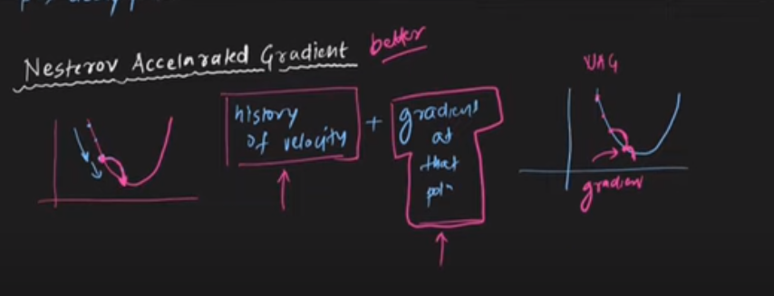

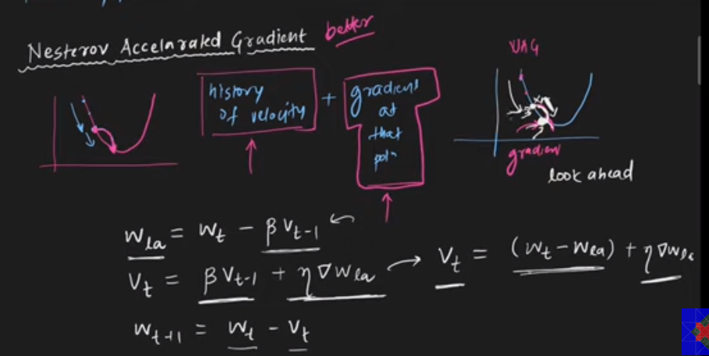

Disadvantage of NAG:
- NAG dampens the oscillations of MOMENTUM, so we can stuck in local minima.

